Stem cell company tells investors, 'Make money and save humanity'

A new investment model will see high net worths sponsor ground-breaking research to wipe out the world's diseases

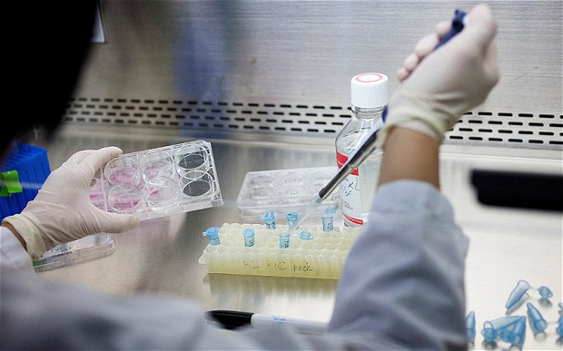
Novagenesis has created a patented technology that allows bone marrow cells to be taken from an individual, reprogrammed, and reinserted into the body
By Rebecca Burn-Callander, Enterprise Editor 2:09PM BST 04 Apr 2015
A small Swiss company has created a novel investment model, where the rewards are far greater than anything financial could bring.
Rather, investors are also paid with technology advancements that could save the lives of their nearest and dearest, or solve their own chronic health issues.
The Novagenesis Foundation and its commercial arm, Ophiuchus Technologies, are pioneers in a niche field of stem cell research. The organisation has created a patented technology that allows bone marrow cells to be taken from an individual, reprogrammed, and reinserted into the body.
The technology is based on the salamander lizard, which can regrow limbs and organs when they are damaged. According to Jørgen Thorball, managing director of Ophiuchus, the company has the capability to heal – and in some cases cure – a variety of health issues.
In Roman mythology, Ophiuchus, also known by his more common name Asclepius, learnt the secrets of keeping death at bay.
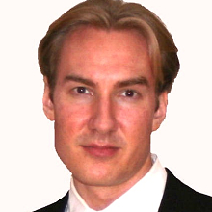
The organisations are raising capital through XOventure, which finds funding and support for early-stage life sciences and biotechnology firms.
Ed Cappabianca, senior partner at XOventure, explains that cures are usually avoided by traditional investors, such as venture capitalists, because once someone is cured, the product is no longer required, which limits its scalability.
“What investors want is a single chemical, something like Viagra, that you can scale and sell for a lot of money,” he says. “Once you start taking it, you tend to keep taking it. It doesn’t solve a problem, so you create a customer for life.
Last year Pfizer made $1.7bn from Viagra sales
“The same is true of many treatments for diabetes. The focus is on creating medicines that allow people to lead healthy, happy lives – as long as you keep taking them.”
Novagenesis has been funded by high-net-worth individuals who are motivated by altruistic or personal reasons to further this kind of research. The not-for-profit foundation has already raised “many millions” to take its technology into clinical trials, and Ophiuchus is aiming to close a £7m investment round.
The company could later also go down the crowdfunding route, Cappabianca claimed, allowing armchair investors to invest in the firm. “The early data will help us to secure the next round of funding as we don’t want to IPO too early,” says Cappabianca. “The stock price will be driven up as people hear about us and the last thing you want is to have a steep valuation when you’re looking to raise more money.
“We want to raise money at a lower price, giving early investors a return, but leaving something on the table for the next guy. That way we can keep going back to the well.”
One private investor, Serge Richard, who manages the Swiss branch of a global estate planning business, said he was attracted to the proposition because of its human dimension. “I believe it will create progress for humanity as a whole, not just for a few people,” he says, “Everyone knows somebody who has been hurt in an accident and left disabled or brain damaged and that could all be avoided with this technology.”
Most of Novagenesis’s backing has been provided by a single donor with progressive multiple sclerosis, a form of the disease where symptoms get continually worse over time rather than having relapses and remissions. Cappabianca also got involved with the project because of personal reasons. “A friend has progressive MS,” he says. “I don’t know if we’ll solve the problem in time for Charlie, but it is why I wanted to help raise the money.”
Ophiuchus’s work is currently focused on spinal cord injuries. The foundation’s founder, Jan-Eric Ahlfors, who invented the new technology, chose to target the most severe cases of paraplegics in order to leave no doubt that the science and product concept was robust.
“Most researchers go for the low-hanging fruit,” says Thorball. “But it actually makes sense to try and solve the most difficult problems first because then you know the technology works.”
Ophiuchus has embarked on its first human clinical trials. The trials are being undertaken in Russia, supported by the country’s leading health body, the Federal Research Clinical Centre of Federal Medical & Biological Agency. There will be 30 patients in the current trial.
Ahlfors is working on the core technology in a private lab in Montreal, Canada, and will publish a paper on his research when the current set of clinical trials are complete.
Novagenesis has kept its research under wraps to avoid creating false hope among the paraplegic community, and sufferers of other diseases, who could eventually be helped by the technology. “We didn’t want to create hype before there was a product,” says Thorball. “The science is interesting but it’s not relevant for the patient, only products are relevant. When science says we can cure something and there is no product, what does the patient do?”
Unlike other stem cell methodologies, Ahlfors is focusing on an “autologous” process, which ensures that the cells are not rejected by the patient, unlike experiments using cells harvested from other sources.
One barrier to growth is that different governments have varying laws on whether an individual can have their own cells harvested. This is not currently possible in the UK or US.
“It seems ridiculous to tell people that they cannot have their own cells, but the regulations are very different depending where you are in the world,” says Thorball.
Other companies have allegedly made headway in stem cell research. Last year, the BBC’s Panorama programme followed the treatment of one paralysed man in Poland, who was filmed walking again for the first time after his accident. Thorball warned against taking claims made by stem cell researchers that are based on a single selected patient.
“In that case, the spinal cord was not severed, just damaged,” says Thorball. “He already had some ability, so the regrowth is a matter of discussion.”
Ophiuchus will work hard towards rolling out treatments in private clinics within two years. The company is aiming to create a mass-market product within a decade. Investor Richard said: “All the insurance companies will begin covering the treatment because even though it will be expensive, it will be much less expensive than treating people for the rest of their lives for a disease, or keeping them in a wheelchair.”

